Task 2: Query the world database
To return a list of records where the Region is Australia and New Zealand,
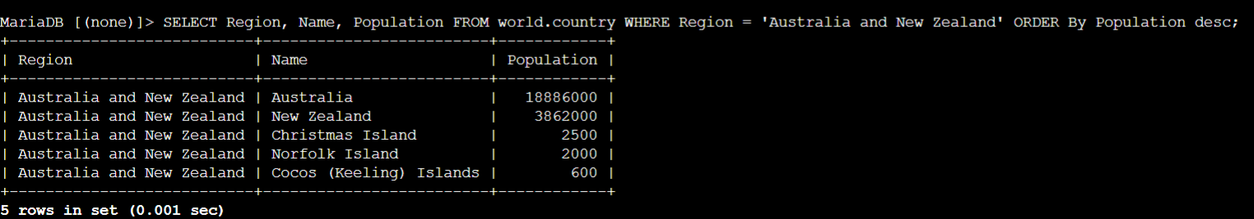
You can use the GROUP BY clause to group related records together.
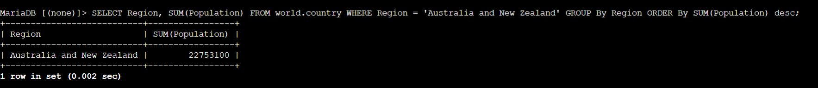
The following example uses a windowing function to generate a running total by adding the Population of the first record to the Population of the second record and subsequent records.
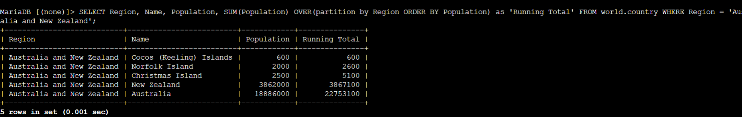
The following query groups the records by Region and orders them by Population with the OVER() clause.
